**Lesson 10 Demo 1**

**Setting up Terraform**

**Objective:** To install and set up Terraform

**Prerequisites:** You need to have Python 2.7 or higher, minimum 8 GB RAM, and SSH or SCP communicator.

**Tools required:** Ubuntu terminal

**Steps to be followed:**

1. Downloading the appropriate package
2. Adding the binary file into the bin directory

**Step 1: Downloading the appropriate package**

1. Click on the URL given below and install the package suitable for your OS (For lab you can click on 64 bit Linux):

<https://www.terraform.io/downloads.html>

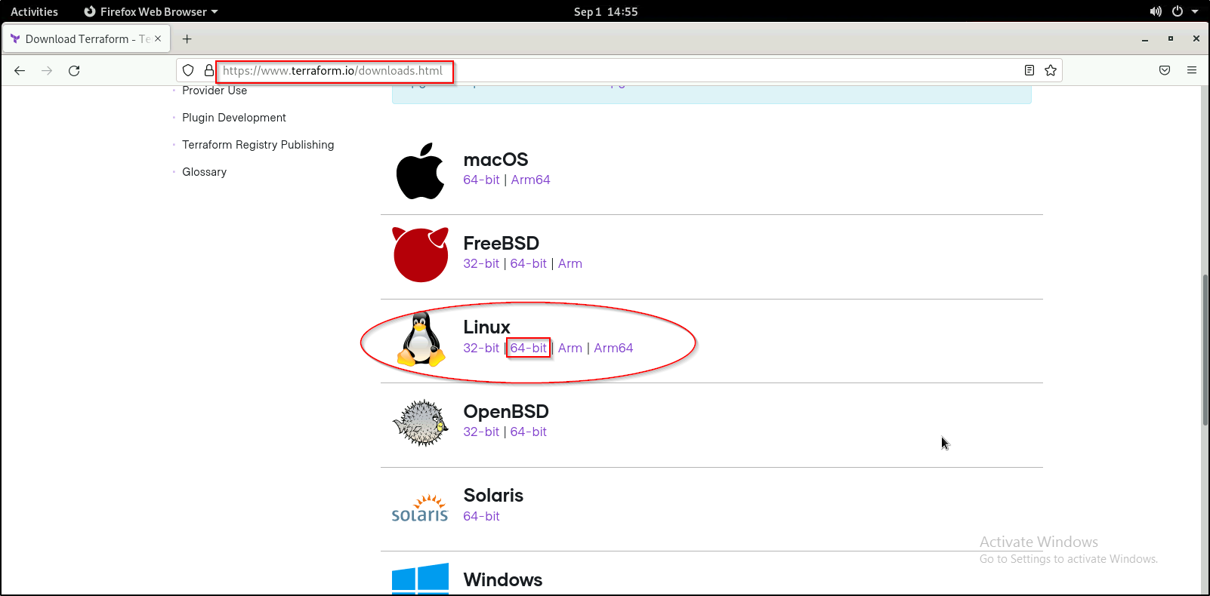

**Step 2: Adding the binary file into the bin directory**

1. Run the below set of commands to unzip and move the Terraform binary file to the bin directory:

***cd Downloads***

***ls***

***unzip <YourTerraformFileName>.zip***

***sudo mv terraform /usr/local/bin***

***cd ..***

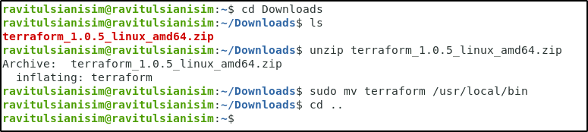

1. You can verify the terraform installation using the command given below:

***terraform -version***

